PLANETARY HEALTH TRANSECT
Route Briefing for Participants

Kathmandu → Chitwan → Pokhara → Lower Mustang (Marpha) → Upper Mustang
This briefing is designed to help participants understand what they will observe while traveling each stretch of the transect. Read the relevant section before departure or during travel. Each section covers what to expect in terms of geography, geology, ecology, climate, settlements, culture, and land use.
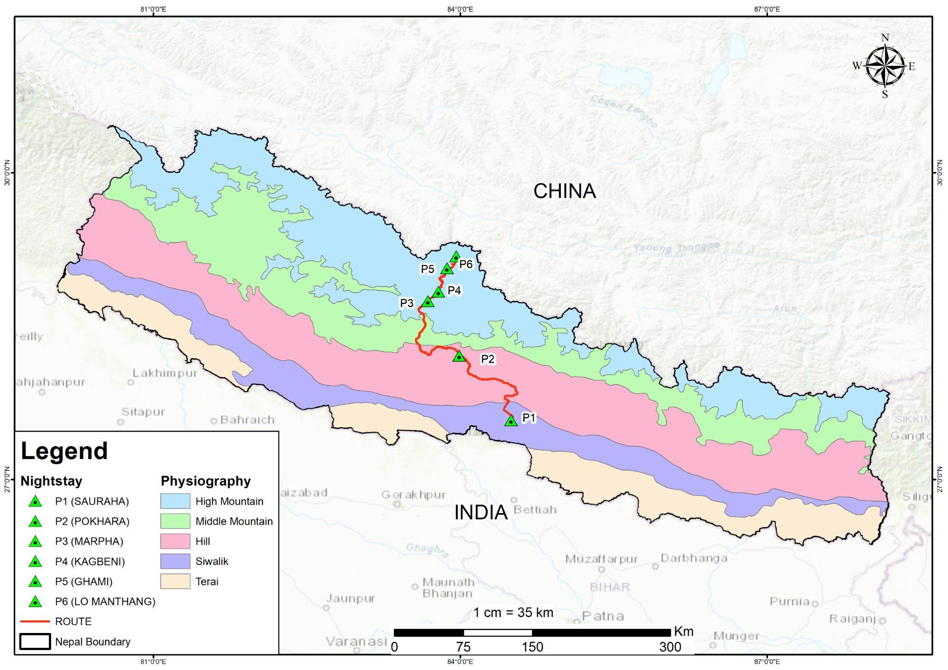

Stretch 4 | Lower Mustang to Upper Mustang

Landscape & Topography

Lower Mustang
The landscape is characterised by fertile valleys, lush apple orchards, and traditional stone-built Thakali villages. The valley floor is relatively broad around Jomsom, with views of the towering Nilgiri and Dhaulagiri peaks.

The Transition: Kagbeni
Kagbeni village (2,800 m) serves as the formal gateway to Upper Mustang. North of this point, the greenery of the lower orchards fades, and the trans-Himalayan desert appearance becomes dominant.

Upper Mustang
You enter a rugged terrain defined by dramatic cliffs, barren ridges, and thousands of man-made "sky caves" carved into the mountainsides. The soil is primarily Aridosol, typical of desert regions, often containing accumulations of salts and lime.

The Road: Marpha to Lo Manthang
This section enters the former Forbidden Kingdom of Lo, a high-altitude cold desert characterised by medieval landscapes and extreme aridity.
- Geographical and Topographical Views: The terrain is a rugged, high-altitude desert (3,500 m to 4,000 m+) defined by dramatic cliffs, barren ridges, and thousands of man-made "sky caves" carved into vertical walls. The Kali Gandaki River here carves one of the world’s deepest gorges.
- Geological Features: The region is famous for Tibetan-Tethys sediments, which include ancient marine fossils like shaligrams (ammonites), proving the area was once an ocean floor. The soil is primarily Aridosol, typical of deserts, often containing accumulations of lime and salts.
- Ecological Experience: Located in the trans-Himalayan rain shadow, the area receives exceptionally low precipitation — Lo Manthang averages only 163 mm annually. The vegetation is sparse, consisting mainly of thorny plants, hardy cereals (buckwheat, barley), and alpine pastures that are currently degrading due to climate change.
- Slopes and Hazards: While traditional monsoon-driven landslides are less frequent, travelers experience "dry landslides" and significant wind erosion. The primary ecological crisis here is water scarcity, which has forced entire centuries-old villages like Dhye and Samjong to relocate as springs dry up.

Geology
This region is famous for Tibetan-Tethys sediments, which contain ancient marine fossils known as shaligrams (ammonites), proving that this high-altitude desert was once an ocean floor. The dominant soil type is Aridosol — desert soil characterised by low organic content, accumulation of salts and calcium carbonate.
What to Observe: Look up at the cliff faces — can you spot the holes and caves cut into the rock high above the valley floor? People lived in these. Look down at the river boulders and you may find spiral fossil shapes pressed into the dark stone; these are the remains of sea creatures from when this land was an ocean floor, long before the Himalayas existed. Also look for signs of water scarcity: dried-up ponds, empty channels, or fields that are no longer farmed. Some of these were abandoned within living memory.

Climate & Temperature
- Rain Shadow Effect: Both regions lie behind the main Himalayan range, but Upper Mustang is even more profoundly affected. While most of Nepal experiences heavy monsoon rains, Upper Mustang remains mostly dry during the summer (July–September), making it a rare year-round trekking destination.
- Extreme Aridity: Precipitation is exceptionally low. Lo Manthang in Upper Mustang receives an average of only 163 mm of rain annually. Water scarcity is a major challenge, leading to the drying of traditional water ponds and the desertification of formerly cultivable land.
- Winter Extremes: Upper Mustang is one of the coldest regions in Nepal. During winter (December–February), temperatures can plummet to -20°C or even -30°C at night.
- Summer / Spring: In the warmer months, temperatures are more moderate, ranging between 0°C and 10°C, though they can reach up to 26°C in some sun-exposed areas.

Climate Change & Environmental Stress
Travelers may observe the physical evidence of environmental stress in Upper Mustang. Research in villages like Dhye indicates a positive temperature trend (warming) combined with a negative precipitation trend (drying). This has forced some communities to relocate as their traditional water sources for irrigation and drinking have run completely dry.

At-a-Glance Summary
Feature | Lower Mustang | Upper Mustang
Primary Vegetation | Apple orchards, temperate forests | Sparse shrubs, barren ridges
Landscape | Broad valleys, stone villages | Cliffs, medieval caves, walled cities
Precipitation | Low (rain shadow) | Extremely low (<250 mm/year)
Soil Type | Mixed mountain soil | Aridosol (desert soil)
Typical Winter Temp | Cold but manageable | Extreme (-20°C to -30°C)

Planetary Health Transect | Route Briefing Document

